Christopher Ward
AMZN Stock Simulation

After downloading a csv of the stock data for AMZN from Yahoo Finance, the first thing I did was plot the opening prices in excel:

After plotting the prices, next I was tasked with finding a rolling average price for the AMZN stock. I used the smoothing method created during the “Plot, Salt, Smooth” project to find the average prices and plot them again in excel, adding a trendline to see how the stock performs:
Next, I overlayed the original data with my smoothed data to create the moving average trendline:

At first my algorithm to make decisions about the stock did not use the smoothed data to help make those decisions. So, my flawed algorithm bought 5 shares of stock if both the opening price and the previous day’s closing price were greater than the previous day’s opening. This was a skewed way to judge whether the stock was on an uptrend and whether the program should buy shares. The only time my program would then sell those shares is when the opening price is greater than the previous day’s by at least 7%. The output of that simulation is below:
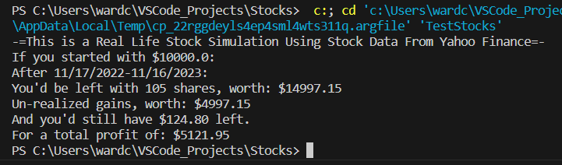
The flawed algorithm did surprisingly well with the $10,000 given, but the next step was to see whether using the smoothed stock data could help my program perform better.
The flawed algorithm will likely not perform well with a stock that’s trending down. So, I implemented the smoothed data to help my program make better decisions. The new algorithm was based on the old one, however now the program only buys shares when the opening price is lower than the average price. Also, it will only sell its shares when the opening price is 5% higher than the average price, we only sell shares above average for greatest change of making profit. The results of running my improved algorithm against AMZN data:
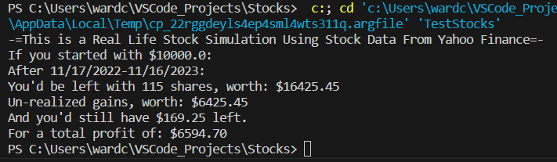
This algorithm performed a lot better than my original one, making ~$1450 more than the first one. After only one year in this simulation, we gained 64.25% of our money, that’s an enormous gain in the stock market.

The stock I used was on an upward trend the entire time, but what would happen if we used a stock that was trending down? So, I grabbed stock data from Moderna (MRNA) and ran my program against it to see what would happen.
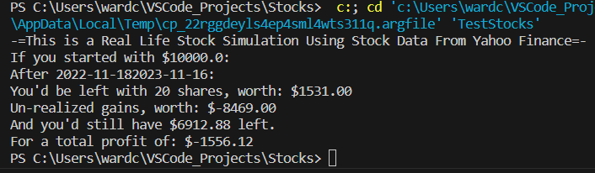
After one year, I’m left with un-realized gains worth $-8469.00 and total profit of $-1556.12, which is horrible. I realized the program doesn’t have cases for if the stock is on a downward trend, it’ll just buy stocks and hold them until they are worth more than when purchased. This is very bad for stocks that keep losing value.

So, finally I added a case where if the opening price is less than or equal to the price when we last bought shares multiplied by .9, meaning when its 10% lower we sell our shares to mitigate losses. The results of that simulation are below:
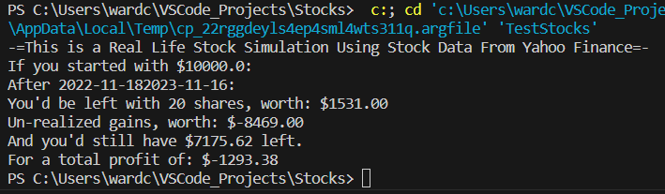
The extra case helped save a couple hundred dollars, but in the end we are still in debt.

